Ly Tu Trong Technical College of Ho Chi Minh City
Basic Science Department - English group
Subject: ENGLISH 1
Class: 15TC-Ô Classroom: H13.13
Date of teaching: 20/01/2016
Allowed time: 1 period
Lecturer: Phạm Thị Thu Hiền
LESSON PLAN
UNIT 4: HOW OFTEN DO YOU DO YOGA?
READING: HAVING FUN FOR FREE.
- OBJECTIVES:
+Improve their reading skill: scanning and skimming skill.
+Enlarge the vocabulary about the leisure activities and famous places in some countries.
+Be able to talk about their hobbies and free time
- METHODS:
Intergrated, mainly communicative.
- TEACHING AIDS:
Pictures, blackboard, textbook, cassette, chalk, handouts.
- TIME:
-45 minutes.
- PROCEDURES
A.Greetings.
B.Checking students’ attendance: 3 minutes
C. Checking the old lesson: 5 minutes
D.New lesson

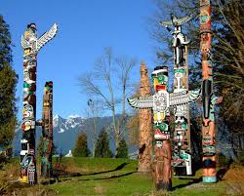
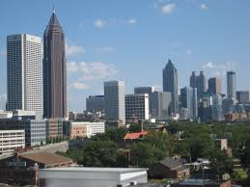
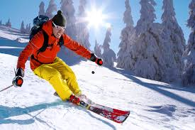
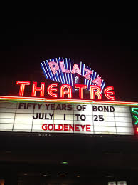
LESSON’S CONTENT | TIME | TEACHER’S ACTIVITIES | STUDENT’S ACTIVITIES
Pre-reading:  Warm up  While- reading  Post- reading | 5 mins  20 mins  9 mins | -Greeting.  -Teacher (T) asks Students (Ss) to close their books first.  -T shows photos of four countries and elicits Ss to give the names of these countries.  -T divides class into small groups.  -T delivers the handouts.  -T gives each group one specific question to discuss about famous sports in above countries.  -T asks students to choose the two most popular cities and sports for each following country given in the handouts.  -T asks a representative of each group to go on the board and write down the answers.  -T gives more information about the culture of some countries.  -T asks S to open the book.  -T focuses Ss to describe the pictures in the article.  -T asks these questions:  +What is the title talking about?  +Where are these places?  +What do you know about them?  -T plays the recording and has S read the article individually.  -T requests S to underline all the Vocabulary they don’t know.  -T writes down new vocabulary on the board, shows the pictures and explains the meanings.  Outdoor, movie theater, ski, terrific, downtown, wildlife, concert, totem-pole.  -T models to read aloud each word.  -T calls some S to practice pronouncing the new words.  -T has S to check the correct boxes.  -T checks answers.  -T asks Ss to focus on the four questions activity 3.  -T writes them on the board and reads them aloud to the class.  -T has Ss read the questions one at a time.  -T elicits the answer from the class.  -T calls some Ss to write the complete sentences on the board.  -T writes the following question on the board: What fun things can you do for free in your city?  -T elicits some answers from the class and writes down all the sentences on the board.  -T asks Ss to work in groups and to discuss the question.  -T elicits answers from each group.  -T asks Ss to write them on the board. | -Students close their book.  -Ss look at the photos and answer.  Expected answer: Japan, America, Canada, and Australia  -Ss work in group and discuss.  -Ss write down their answers on the board.  -Ss open their books.  -Ss answer these questions individually.  -Ss listen the recording and stay focused on the words they don’t know.  -Ss give T new words.  -Ss focus on how to pronounce new vocabulary and read aloud.  -Ss check the correct boxes.  Expected answer:  Brian: beaches, music, parks.  Sarah: markets, mountains, parks.  -Ss pay attention on the questions.  -Ss read and answer the question.  Expected answers:  1.A park.  2.In January.  3.You can ski in the mountain and swim in the ocean on the same day.  4.No, it isn’t.  -Ss give T some ideas to answer the question.  -Ss work in small group, exchange the ideas.  -Ss write them on the board.  Possible answers:  -You can go to the park.  -You can go to visit the museum.  -You can go to the outdoor markets.

- SUMMARY OF UNIT 4:
-T reminds students about:
+Vocabulary and Grammar exercises.
- HOMEWORK:
-Students have to do again all the exercises.
-Students prepare for the next part.
January, 20th 2015
ADOPTION OF ENGLISH GROUP Teacher’s signature

Phạm Thị Thu Hiền

CHOOSE THE TWO MOST POPULAR CITIES AND SPORTS FOR EACH COUNTRY.
SPORTS: SUMO, SKI, SOCCER, BASEBALL, FOOTBAL, TENNIS, BASKET BALL, ICE HOCKEY, KENDO
CITIES: SIDNEY, WASHINGTON DC, TOKYO, MELBOURNE, VANCOUVER, NEW YORK, TORONTO, OSAKA, SEOUL, BANGKOK

PICTURE 2
PICTURE 1
PICTURE 3
PICTURE 4
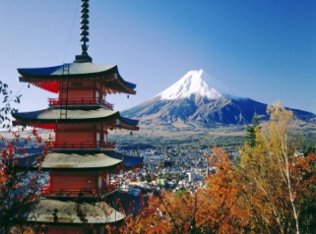
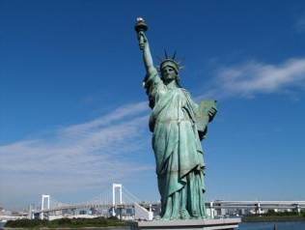
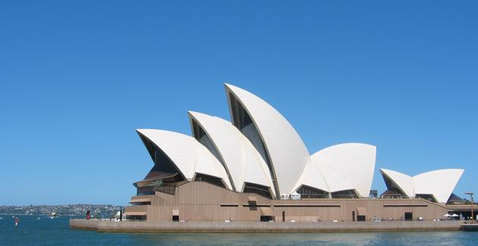


NAME

CITIES

SPORTS

